

SIMATS ENGINEERING
Saveetha Institute of Medical and Technical Sciences Chennai- 602105
Student Name: MONISH. L Reg. No.: 1972260035
Course Code: CSA0702 Slot: C
Course Name: Computer Network
Course Faculty: Dr. G Kumaran

Project Title: For a network node under variable load (P), can a Priority Queuing model (I), rather than a single FIFO queue (C), improve QoS measures like waiting time and throughput (O)?
Module Photographs: (3 photographs –Module Photo, Individual student contribution module work in the project and presentation image)
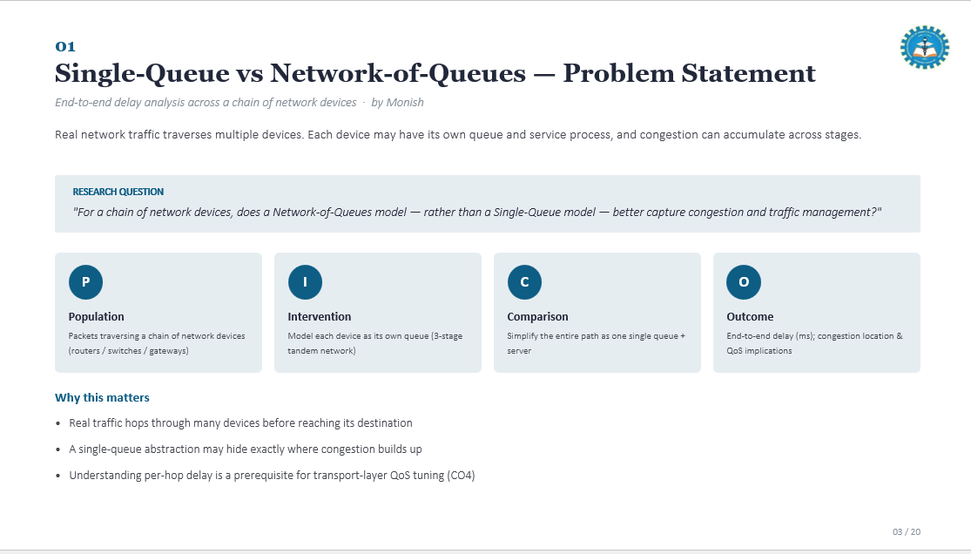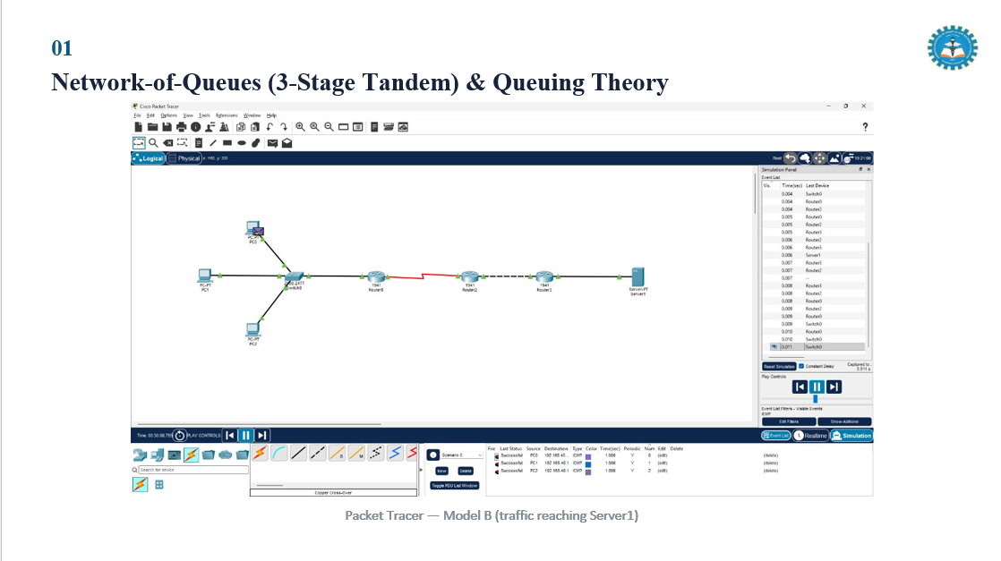
Project Description: Modelled the 3-stage tandem queue and Packet Tracer topologies Built and ran Packet Tracer Models A and B; recorded end-to-end delay
Module 1 – Single-Queue vs Network-of-Queues investigates whether modelling a chain of network devices as a 3-stage tandem network of queues captures congestion more realistically than reducing the whole path to a single FIFO queue and server. My contribution covered the problem framing (PICO), the single-queue baseline model, and the tandem queue simulation in Cisco Packet Tracer.
The baseline (Model A) reduces the entire path to one Queue + Server; it is simple to analyse and useful as an M/M/1 theoretical reference, but it cannot localise congestion to a specific device and can mask intermediate bottlenecks. The tandem model (Model B) instead represents each device — router, switch, gateway — as its own Q/S stage, with end-to-end delay W_total = (Wq1+S1) + (Wq2+S2) + (Wq3+S3), following Jackson-network theory that each Poisson-arrival stage behaves as an independent M/M/1 queue.
Both models were built and simulated in Cisco Packet Tracer under identical traffic conditions (λ, μ, packet size, duration). Model A confirmed all pings successful with negligible delay on a Gigabit link; Model B introduced a 64 kbps serial link between routers to expose a realistic bottleneck, with traffic verified reaching Server1.
Results showed an average end-to-end delay of 1.5 ms for the single-queue baseline versus 45.2 ms for the 3-stage tandem model — a 43.7 ms (+2,913%) increase — confirming that per-device queue modelling exposes local congestion that a single queue abstraction completely masks, supporting per-hop metrics as a basis for targeted traffic management and linking directly to transport-layer QoS tuning (CO4). No simulation result reported here is fabricated.

Student Signature Guide Signature

